*Prerequisites:
The following are some prerequisites that users must have prior to running the MOLINA application. Among them are: PC / Laptop / Smartphone, Internet Connection and Web Browser (Google Chrome)

*App Access:
-Open a browser (Google Chrome), then enter the following URL, https://molina.imigration.go.id/.
-Make certain that your network stays connected to the Internet.

*Home page
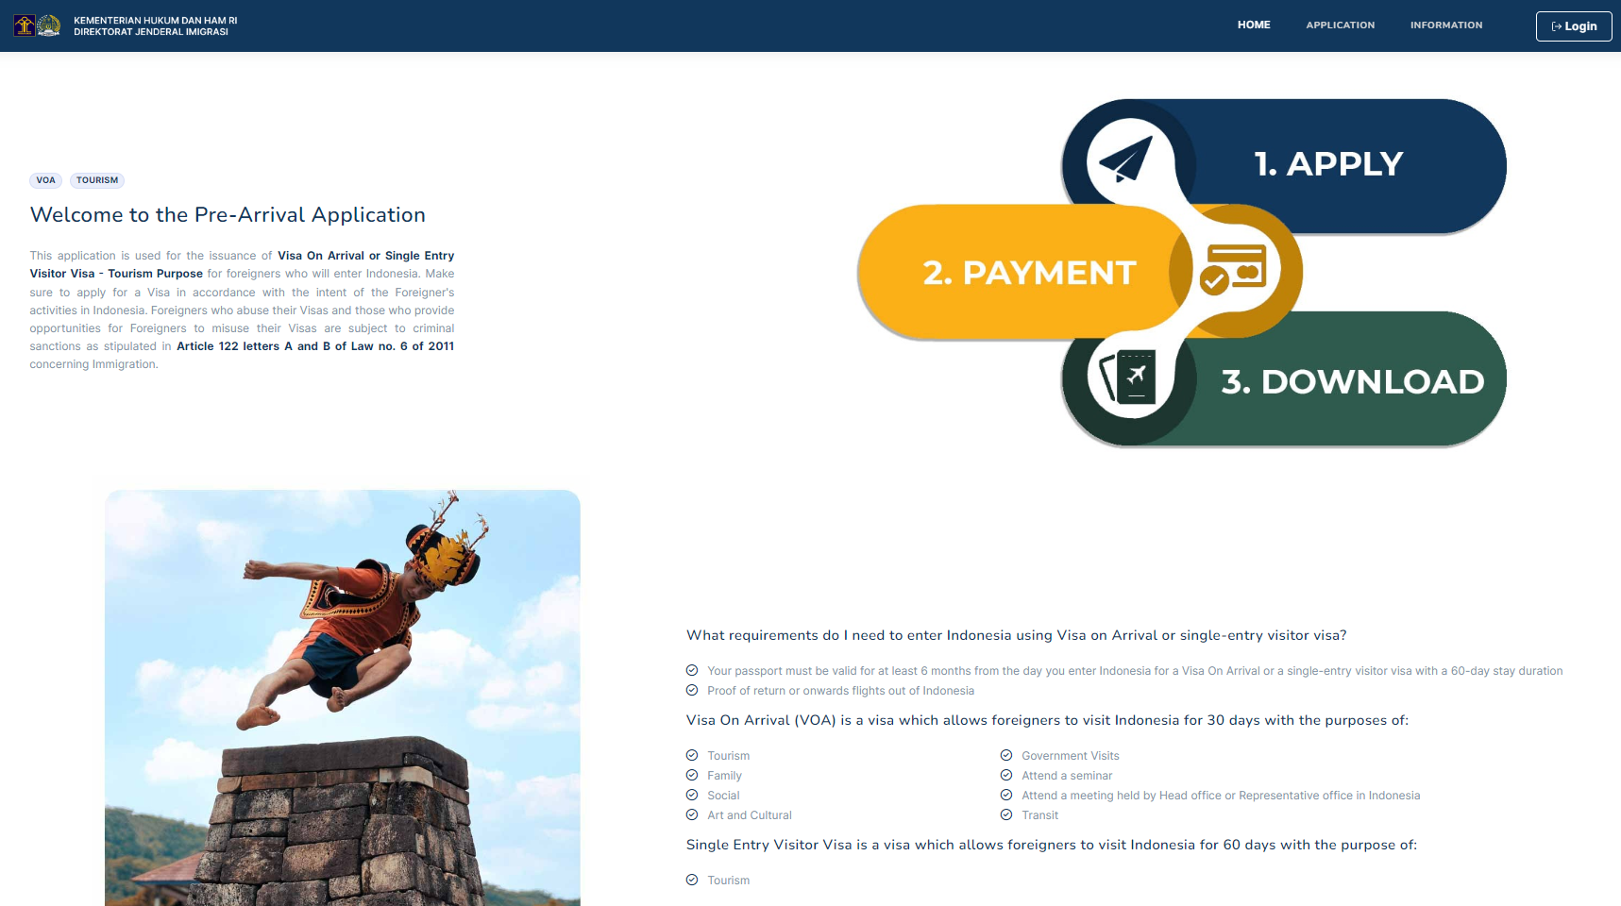
1. Above is the home page of the MOLINA application.
2. On the home page, there is general information about the type of VISA the applicant can apply for, the purpose of arrival and the required supporting documents.
-List of VISAs that can be applied: Visa on Arrival & One-way Visit Visa (Tour Destinations)
-The purpose of arrival for Visa on Arrival: Tourism, Family, Social, Art & Culture, Government Visits, Attend a Seminar, Attend a meeting held by Head office or Representative office in Indonesia and Transit.
-Supporting documents: Your passport must be valid for at least 6 months from the day you enter Indonesia for a Visa On Arrival or a single-entry visitor visa with a 60-day stay duration & Proof of return or onward flights out of Indonesia
3. For further information, users can go the “More Information” button which will redirect to the Information menu.
4. Before applying, the user must have an account and log in using their account. There is a "Login" button that brings the user to the Login Page to enter the application or create an account.
5. Users who already have an account can submit an application by clicking "Apply".

*Login Page
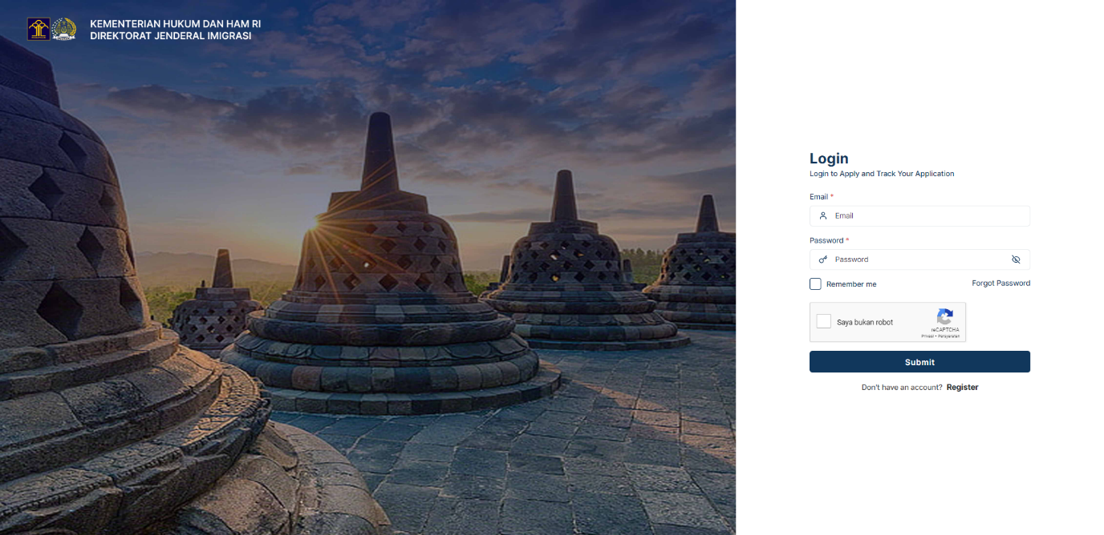

1. Above is the page where users can enter the application by filling in the Email & Password fields and completing the CAPTCHA to submit the application.
2. If the applicant does not yet have an account, they must create an account to apply for a VISA by pressing the "Register" button
3. Users can reset their password by pressing the “Forgot Password” button which will go to the Forgot Password Page.

*Registration Form
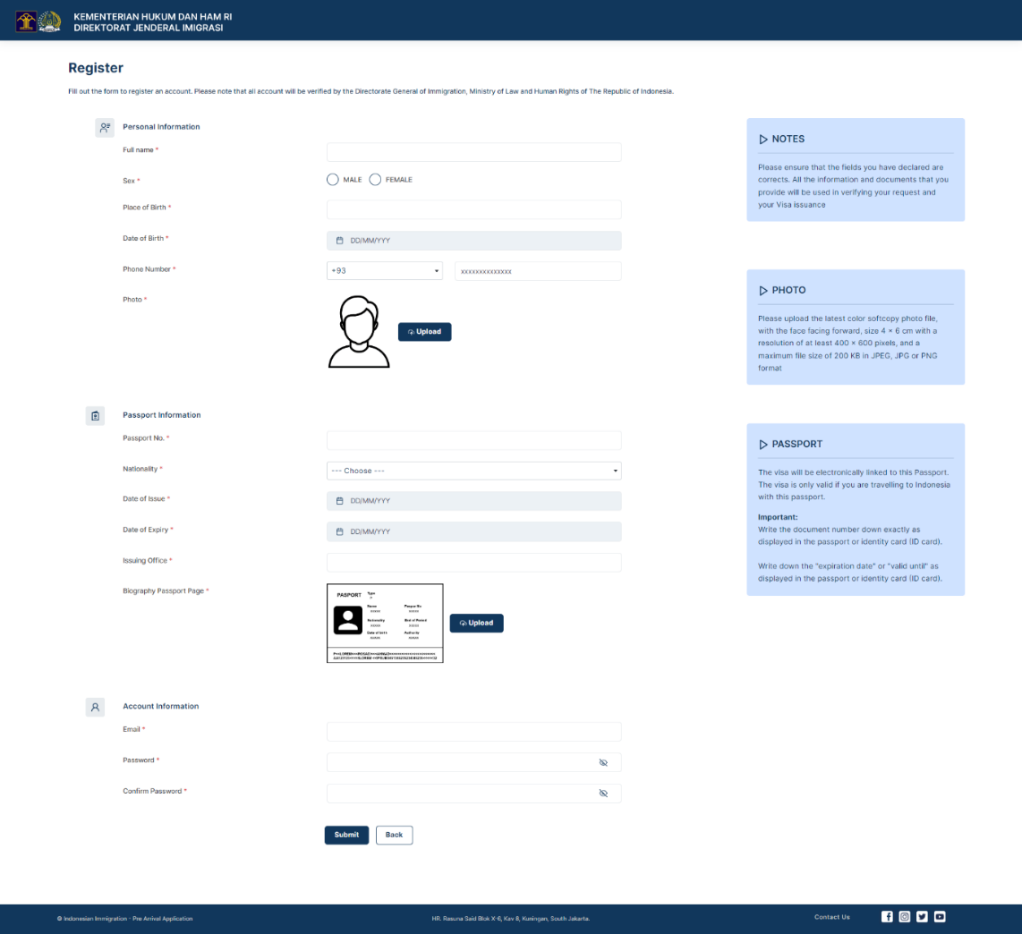
1. Here is the registration form for users to create a MOLINA application account.
2. There is general information that users must fill in, such as Personal Information and Passport which are not needed to be attached when submitting the application.
3. The last information that users must include is Account Information. Users are required to input Email & Password to enter the MOLINA application.
4. Once the information is completed, the user can press the "Submit" button
5. The system will display a pop up message confirming that the account activation link has been sent to the user's email. If the email has not been received, the user can press the "Resend Activation" button
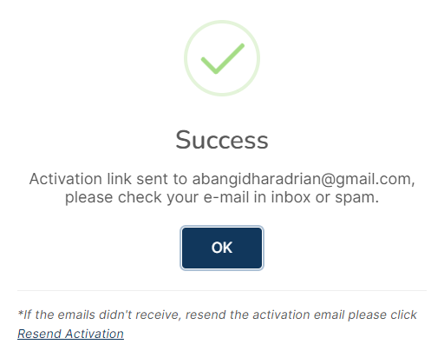
6. There are 2 options for users to activate their accounts, the first is by pressing the “Activate” button and the second is to Copy the link attached in the email and Paste it into the web browser.
7. Once the account is successfully activated, the user can login to the application to submit an application.

*Guide to Forgot Password
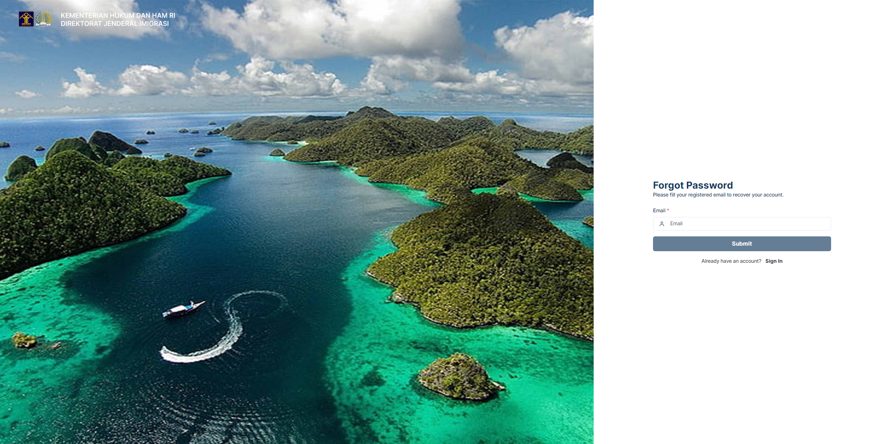

1. Users must enter the Email they used when creating their account, then click the “Submit” button
2. A pop up message will appear to inform you that a link to reset the password has been sent via email. If the email has not been received, the user can press the "Resend Activation" button
*Pop-up messages
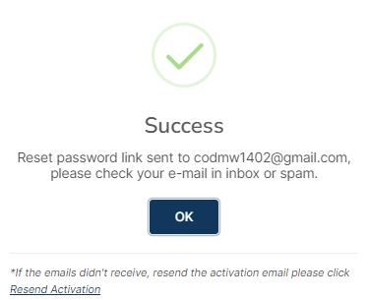

3. The following is the email message that the user will receive.
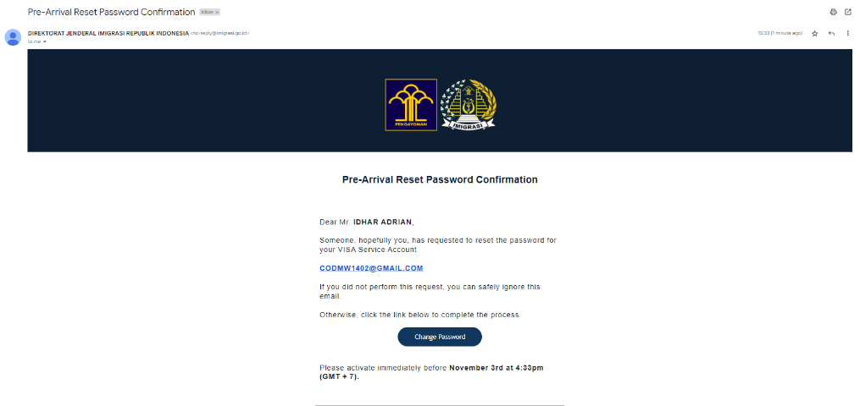
4. Press the “Change Password” button to change the password
5. On this page, users can enter a new Password by typing it in the New Password & Confirm New Password fields.
